Version 4.0

Special Educational Needs and Disabilities (SEND) Policy Written September 2024

Introduction

We begin with stating our firm belief at Emmanuel Christian School that all people are created in the image of God and are worthy of honour, love and respect because of this. Pupils are taught that God designed us to trust Him and that relying on His word makes us strong, and that we can do all things through Christ who strengthens us. Genesis 1:27 Romans 12:2.

  - Emmanuel Christian School works in partnership with parents offering them an education in which they can be fully involved. High quality, individual education pathways are carefully planned around the pupil, ensuring they reach their potential socially, personally, emotionally and academically in all areas of the curriculum.
  - The most recent OFSTED monitoring inspection report received in 2022 said: ‘Leaders have ensured that they communicate the needs of all pupils including those with EHC plans to staff effectively.’

  - Children may have special educational needs or disabilities that require additional support when progress has slowed or stopped. In such circumstances, the SENDCo and support team will consider individualised options.
  - As a team, we are dedicated to meeting the specific and individual needs of our pupils, resulting in a more personalised, pupil centered approach.
“A child or young person has special educational needs if he or she has a learning difficulty or disability which special educational provision to be made for him or her. A learning difficulty or disability is a significantly greater difficulty in learning than the majority of others of the same age. Special educational provision means educational or training provision that is additional to, or different from, to that made generally for others of the same age in a mainstream setting in England….Health care provision or social care provision which educates or trains a young person is to be treated as special educational provision.”

Code of Practice 2014

  - Our Special Educational Needs and Disabilities (SEND) Local Officer.
  - Our local Officer is intended to give you the information regarding the approaches we use to ensure all of our pupils are supported, including those with SEND, in order that they can realise their full potential. This is in partnership with the SEND Support Service in Leicester.

The Local Offer or Summary of Provision for children and young people with special educational needs or disabilities (SEND)
  - We are committed to being a fully inclusive school and aim to ensure all pupils achieve their potential, personally, socially, emotionally and academically in all areas of the curriculum, (regardless of gender, ethnicity, religion, sexual identity, physical ability or educational needs). This is to ensure that each pupil is enabled and supported to reach their full potential in all areas of the curriculum and school life.
  - Children may have special educational needs or disabilities that require additional support when progress has slowed or stopped. We implement a graduated approach based on guidance from Leicester City Council’s Children’s Services for SEN. This is based on an Assess-Plan-Do-Review 3 range structure. (See appendix for explanation.)
  - If a pupil has an Education, Health and Care Plan (EHCP) in place, we provide the support as detailed in their plan.
  - Detailed guidance is available through the Local Authority’s following link:
  - https://families.leicester.gov.uk/send-local-offer/where-to-start-with-send/education-health-and-care-assessment-and-plans/ehc-plan-review/
  - All our staff are involved and committed to providing quality education and support for SEND pupils. The class teacher and support staff have day-to-day responsibility, co-ordinated with the SENCo, for ensuring that academic, social and emotional support is given to all children.

  - Staff give time for your child to communicate and discuss issues that are worrying them, and proactive plans support skills development and differentiated work in lessons.
  - All staff promote independence. Pupils with an Educational Health Care Plan are supported by the class teacher and a designated support staff member, co-ordinated with the SENCo.
  - If you are concerned about your child, please contact their class teacher or one of the staff listed below:-

- Head of Lower School – Mrs S.Seeds (Reception- Year 4)
- Head of Middle School-Mr G.Sutton (Year 5- Year 8)
- Head of Upper School – Mrs L. Hallam (Year 9- Year 11)
- Headteacher – Mr A. Harris
- SENCo – Mrs L. Harris

  - Any enquiries about SEND provision at Emmanuel Christian School should be made to Mrs Libby Harris ( l.harris@ecsleicester.org.uk) .

The Role of SEN Support Staff at Emmanuel Christian School
  - Support staff have high expectations of all pupils and use their subject knowledge to enable pupils to achieve learning objectives in lessons. Teaching staff plan lessons to make effective use of support staff; therefore, their support has a significant impact in contributing to the learning and achievement in our classrooms.
  - Our support staff are also involved in delivering a variety of specific interventions daily. Support assistants provide one-to-one/small group input linked to the pupil’s SEND Plan.
  - Training: The SENCo is responsible for co-ordinating training for staff supporting pupils with SEND. Training is affected through regular case conferences and Pupil Passport or EHCP reviews. Additionally whole school staff training takes place on specific issues facing current pupils such as Autism, Mental Health, Behaviour Management, Emotional Regulation and . Individual members of SEND support staff attend appropriate courses as required. The school is also able to network with partner schools in the Christian Schools’ Trust to provide additional training opportunities and advice.

Aims and Objectives of our SEND Policy:
    - To ensure that every child has equality of access to the National Curriculum at levels appropriate to their capabilities.
    - To identify a pupil's special need and/or disability at an early stage or as soon as it becomes apparent.
    - To implement effective provision and monitor pupil progress accordingly.
    - To assist staff in addressing their SEN responsibilities by sharing information and providing guidance and support.
    - To provide a network of support for children and parents from within school and through links with appropriate outside agencies.
    - To ensure that parents' views and concerns are taken into account when making provision for a child with special educational needs and to ensure there is effective communication between parents and school.
    - To meet the school's legal obligations, working within the guidance provided in the SEND Code of Practice, January 2015.

Identification Of Special Educational Needs
  - At Emmanuel Christian School, it is the belief that all children have an equal right to a full and rounded education and early identification is crucial in ensuring this, in line with the Code of Practice 2015. The four areas of need outlined in the Code of Practice are as follows:
    - Communication and interaction
    - Cognition and learning
    - Social, mental and emotional health
    - Sensory and/or physical needs
  - For any area of need identified, a range of evidence is collected through the normal assessment and monitoring arrangements. If this suggests that a child is not making the expected progress, the class teacher will consult with the SENDCo in order to decide whether additional and/or different provision is necessary. The purpose of identification is to ensure that individual needs are recognised and that provision is put in place to ensure that the child continues to make progress.

  - There are other factors which need to be considered when establishing the reasons a child’s attainment or progress is causing concern. These include attendance and punctuality, health and welfare, EAL, being in receipt of Pupil Premium grant, being a Looked After Child or the Child of serving Armed Forces personnel. These are addressed within other school policies but may still require the teacher to put in additional and differentiated provision to ensure the child makes progress.
  - The school’s system for observing and assessing the progress of individual children will provide information about areas where a child is not progressing satisfactorily. Under these circumstances, teachers may need to consult the SENDCo to consider what else might be done. This review might lead to the conclusion that the pupil requires help over and above that which is normally available within the particular class or subject.
  - All children receive quality first teaching. As the Code of Practice suggests, pupils are only identified as SEND if they do not make adequate progress once they have had all the interventions / adjustments and good quality personalised teaching. High-quality first teaching is the first step in responding to pupils who have or may have SEND.
  - The key test of the need for action is that current rates of progress are inadequate, despite having received targeted intervention. Adequate progress can be identified as that which:
    - Prevents the attainment gap between the child and his/her peers from widening.
    - Closes the attainment gap between the child and his peers.
    - Betters the child’s previous rate of progress.
    - Ensures full access to the curriculum.
    - Demonstrates an improvement in self-help, social or personal skills.
    - Demonstrates an improvement in the child’s behaviour.
  - When any concern is initially noted, it is the responsibility of the class teacher to take steps to address the issue whilst liasing with/communicating to the SENDCo. They are responsible and accountable for the progress and development of pupils in their class, including where pupils access support from teaching assistants or specialist staff.
  - Children will be identified by class teachers, observed by the SENDCo, and targeted intervention may be outlined and delivered for an agreed period. The class teacher will communicate with the SENCo, and be clear about current levels of support and provision.
  - Pupil progress meetings with the SENCo and a member of the SLT will highlight children of concern and initiate discussion as to the best course of action. These meetings are scheduled half termly
  - Should the child still fail to make adequate progress, they will be added to the SEN register at this time with the agreement of parents and more targeted intervention planned by the class teacher and SENCo. This may involve advice and support from outside agencies at this point. The Graduated Approach Plan has incorporated Pupil Passports and target setting. It is based on the Assess-Plan-Do-Review system outlined in the Code of Practice 2015.

Individual SEND Plans
  - The aim of our provision is to identify and assess the SEND and to plan the provision needed for each pupil to achieve their potential.
  - Some SEND pupils may need extra support to achieve their learning potential. If this is the case, then we will meet with the parents and pupil to discuss what is required to put together a SEND plan.
  - Before the Plan can be drawn up we will need to gather the following information:-
    - The pupil’s views and what he / she want to achieve on their learning policy through Emmanuel Christian
School.
    - The views of the parents / carers and what they would like to see as an outcome from their child’s time at
Emmanuel Christian School if applicable.
    - A school based learning assessment
    - Current and expected levels of attainment.
  - Once this information has been collated a SEND Plan will be drawn up. The Plan will include individual learning outcomes, and a date for review.
  - Some SEND pupils may need support from professionals outside of the school setting to achieve their learning potential. If this is the case then the professional’s views will be considered when drawing up the Plan. This could include:
    - Parents / carers seeking medical advice about the child.
    - School requesting the involvement of the Learning Support Services.
    - School requesting advice from specialist disability teams.

  - By drawing up a SEND Plan we are able to coordinate and arrange support to help families who have requested help because their child is failing to make progress in learning and/or social, emotional and behaviour.

Definitions:
  - Educational Health Care Plan (EHCP)
This has replaced the Statement of Educational Needs and includes special educational provision, health provision and social care provision in one document. If the child has an EHCP we will provide the support detailed in the plan. Leicester City Council’s SEND department will be responsible for the EHCP and reviews will be held at least once a year to ensure the pupil’s needs are being met.

Special Educational Provisions - Provision for pupils with disabilities and additional educational needs.
  - Admissions: At Emmanuel Christian School we look at the educational needs of a pupil with SEND and in liaison with the parents and other professionals involved with the pupil we plan a comprehensive learning package which allows for measurable learning opportunities to be put in place.
  - Discrimination: We have an Equality Policy at Emmanuel Christian School to ensure that every pupil is provided with equal opportunities to access all aspects of our curriculum.
  - Additional Educational Needs: We are confident that every pupil with additional educational needs currently on roll at Emmanuel Christian School is provided with an educational support package designed to cater for their individual needs. If you have any further questions please do not hesitate to contact the Headteacher, or the SENDCo.

Policies relating to SEND
  - A range of policies underpin our SEND offer; in particular these are:
    - Anti-Bullying Policy
    - Attendance Policy
    - Safeguarding and Child Protection Policy
    - Equality Policy
    - Health & Safety Policy
    - Behaviour and Discipline Policy
    - Positive Handling Policy
    - Special Educational Needs Policy
    - Statement of the Education of Looked After Children
    - Looked After Children Policy
    - Teaching & Learning Policy
    - SEND Report

Links with outside organisations
  - Emmanuel Christian School works in partnership with many different agencies to enable a supportive plan to be
developed to meet your child’s needs.
  - Listed below are some of the outside agencies with whom we work collaboratively:
    - Leicester City SEND Support Service Teams:
Social and Emotional and Mental Health Team (SEMH)
Learning communication and Interaction Team (LCI)
Speech and Language Therapy Team (SALT)
    - Leicester Educational Psychology Team
    - Child and Adolescent Mental Health Services (CAMHS)
    - Early Help

Looking after the Learning progress of pupils:
  - with temporary / long term medical needs by:
    - Supervising and recording the administration of prescribed medicines.

who have been placed on the Child Protection Register by:
    - Ensuring that confidentiality is maintained and that the pupil is provided with a discreet and confidential individual support package within the school setting.
    - Attend core group meetings to ensure protection plan is adhered to.
    - Liaise with other professionals.
    - Key/ trusted adults available during the school day to provide support for the pupil if required.

with temporary / long term behaviours which impact on them accessing full time mainstream education by:
    - Providing a facility within school (the garden and foyer) whereby pupils can receive learning / social and emotional support in order that they are able to access mainstream curriculum lessons under the supervision of support staff.
    - Providing behaviour support plans and individual learning programmes for pupils so that they will achieve academic success as well as social / emotional support to address overcoming learning barriers.

Review
  - The policy was written in September 2024 and will be reviewed annually.
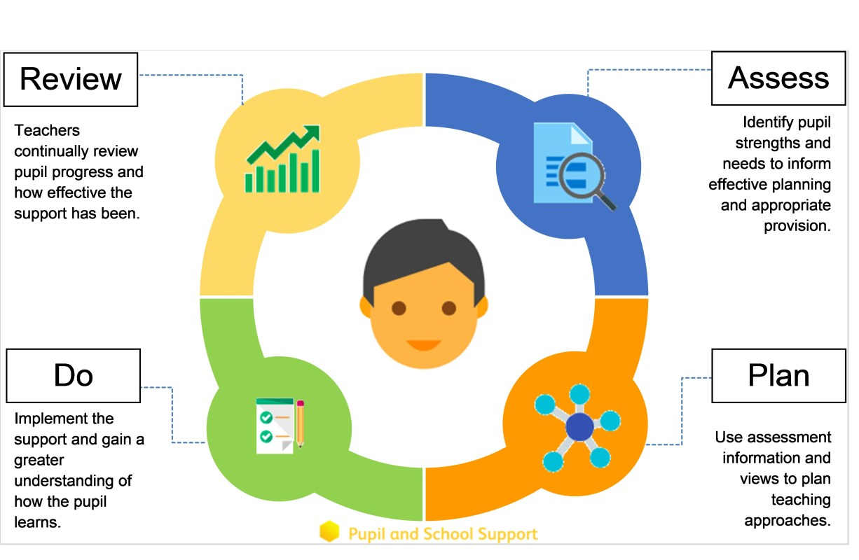
Appendix

Formally agreed through Governors compliance:
Signed Chair of Governors
Signed – Head Teacher
Review Date: | September 2025

